VEHICLE SERVICE MANAGEMENT SYSTEM
ABSTRACT
A Vehicle service management system is a part of an application in showroom or vehicle center. When customer need to promote the service in vehicle shop no need to provide vehicle in vehicle service center. Customer just visit this software then create an account themselves. The main work of admin is that create a branch and branch details, every user should have own account to use this application. Customer visit the service registration form and submitting the request once it’s completed service center workers can able to see the customer service request. Also, admin can check the billing details as date wise and branch wise details.
Our project vehicle service is a system application we create a website regarding the service appointment, pay bill for vehicles services, Spare parts, etc. vehicle application is use full for automobile workshop customers and its employees.
SYSTEM SPECIFICATION
HARDWARE SPECFICATION:
- Processor : P 4 700 GHz.
- RAM : 4GB RAM
- Hard Disk Drive : 40 GB HDD

SOFTWARE SPECIFICATION:

  - Operating System : Windows XP/7/8/10
  - Front End : JAVA
  - Back End : MY SQL

SYSTEM STUDY
EXISTING SYSTEM:
In this existing the customer need to give a service then they went to service center and waiting a long time for service our vehicle. We need to sell or a purchase a vehicle is more irritating for us.
DRAWBACKS:
The existing system has the following drawbacks.
- Someone don’t know about service center which is best
- We don’t compare to the other service center so the money was waste.
- Waste of Time

PROPOSED SYSTEM:
The customer is supposed to take an appointment for their vehicle to be serviced. At most first, the customer is supposed to register his/her name, their personal details including their contact no and email id. Next, they are supposed to enter their vehicle information. As soon as they take an appointment, an appointment number will be given to them included with the date and time of the vehicle service. This will be generated by the automated system. The receptionist will note down this appointment number and on that particular day, the number will be verified with the customer.
FEATURES:
- It tracks all the information about the customer
- Easily Maintaining daily service profit details
- User easily identify vehicle quality
- Maintain user feedback
DESCRIPTION OF MODULES
Customer Registration
Here user can manually create registration by collection some fields datas like, user name mobile number, address etc.…using username and password to login into this application. This is an first entry module to collect the information from the user.
Branch Registration
In this module user can create the different branch, based on this branch user can submit the service. This module will be handling several branch details in a single screen and user friendly.
Service Registration
When user need to service their vehicle use this module and request to the service center. Which module collect the all the information about the vehicle.
Customer Details
Admin can check all the customer’s details if admin need to contact the customer information can get easily. Also admin have access to delete customer due to any un-necessary customers.
Billing Details
In this module user and admin saw the detail about billing details, we can see the billing details as a date wise and branch wise.

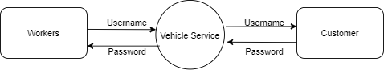

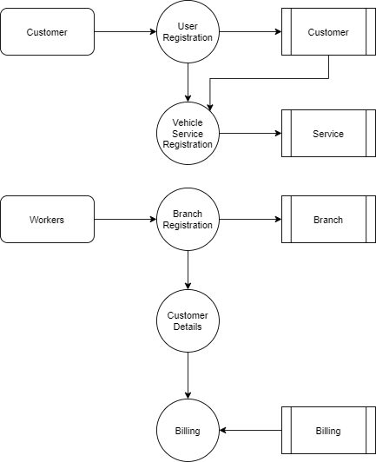

TABLE NAME: BRANCH
FIELD | DATA TYPE | SIZE | CONSTRAINT
Branch id | Int | 10 | Primary key
Branch name | Varchar | 20 | Not null
Land mark | Varchar | 20 | Not null
Pincode | Int | 6 | Not null
address | Varchar | 30 | Not null

TABLE NAME: CUSTOMER
FIELD | DATA TYPE | SIZE | CONSTRAINT
Customer id | Int | 10 | Primary key
First name | Varchar | 20 | Not null
Last name | Varchar | 20 | Not null
Email | Varchar | 20 | Not null
Age | Int | 10 | Not null
Gender | Varchar | 10 | Not null
Mobile | Int | 10 | Not null
Password | Varchar | 20 | Not null
Address | Varchar | 30 | Not null

TABLE NAME: SERVICE
FIELD | DATA TYPE | SIZE | CONSTRAINT
Service id | Int | 10 | Primary key
Customer id | Int | 10 | Foreign key
Branch id | Int | 10 | Foreign key
Vehicle type | Varchar | 30 | Not null
Vehicle number | Varchar | 20 | Not null
Problem | Varchar | 30 | Not null
Address | Varchar | 30 | Not null
date | Date | 10 | Not null

TABLE NAME: BILLING
FIELD | DATA TYPE | SIZE | CONSTRAINT
Billing id | Int | 10 | Primary key
Branch id | Int | 10 | Foreign key
Service id | Int | 10 | Foreign key
Amount | Int | 10 | Not null
date | Date | 10 | Not null

